OP484 OP-AMP
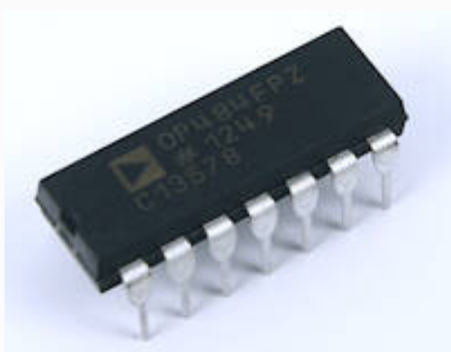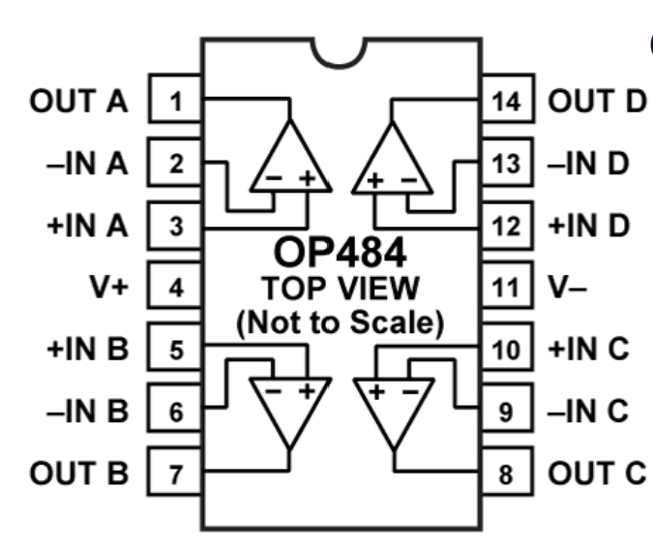

- Single-Supply Operation
- Wide Bandwidth: 4 MHz
- Low Offset Voltage: 65 µV
- Unity-Gain Stable
- High Slew Rate: 4.0 V/µs
- Low Noise: 3.9 nV/√Hz
OP484-to-system connections
OP484 pin | Function | Connect to
1 | Channel A output | Oscilloscope probe/output test point
2 | Channel A inverting input | Gain resistors
3 | Channel A noninverting input | AC-coupled AD9833 output
4 | Positive supply | ESP32 board’s USB-derived 5V/VIN pin
/5 | Channel B noninverting input | Raw 2.5 V reference
6 | Channel B inverting input | Pin 7
7 | Channel B output | Buffered 2.5 V reference
8–10 | Channel C | Configure safely as described below
11 | Negative supply | ESP32 GND
12–14 | Channel D | Configure safely as described below
Confirm that your board’s 5V or VIN pin measures approximately 5 V while powered by USB before connecting pin 4. Do not connect OP484 pin 4 to the ESP32’s 3.3 V pin.
Power and bypassing
Connect:
ESP32 5V/VIN ───────── OP484 pin 4
ESP32 GND ───────────── OP484 pin 11
Place these near the OP484:
- 100 nF ceramic capacitor between pins 4 and 11
- 10 µF electrolytic between pins 4 and 11
  - Positive lead toward pin 4
The ESP32, AD9833 and OP484 must all share the same ground.
Build the 2.5 V reference
Use two equal resistors:
ESP32 5V ── 10 kΩ ──┬── 10 kΩ ── GND
│
VREF_RAW
Then connect:
VREF_RAW ───────── OP484 pin 5
OP484 pin 6 ────── OP484 pin 7
Add:
- 10 µF from VREF_RAW to ground
- 100 nF from VREF_RAW to ground
Pin 7 is now the buffered 2.5 V reference, VREF.
Before continuing, measure:
- Pin 4 to ground: approximately 5 V
- Pin 5 to ground: approximately 2.5 V
- Pin 7 to ground: approximately 2.5 V
Connect the AD9833 to channel A
Use an AC-coupling capacitor to remove the AD9833’s DC bias:
AD9833 OUT ── 1 µF ──┬──── OP484 pin 3
│
100 kΩ
│
OP484 pin 7, VREF
A nonpolar film capacitor is preferred. A ceramic capacitor can be used for the initial test. If you only have polarized electrolytic capacitors, pause before installing one because its polarity depends on the measured voltage on each side.
Gain-of-two feedback
Connect:
OP484 pin 1 ── 10 kΩ ── OP484 pin 2
OP484 pin 2 ── 10 kΩ ── OP484 pin 7
This gives:
$$A_{v}=1+\frac{10k}{10k}=2$$
For an AD9833 output of approximately 0.60 Vpp, pin 1 should show approximately:
$$V_{\text{OUT}}≈1.20\text{ Vpp}$$
centered around 2.5 V.
Unused channels
Prevent the unused op-amps from floating by configuring them as 2.5 V followers.
Channel C:
Pin 10 → pin 7
Pin 9 → pin 8
Channel D:
Pin 12 → pin 7
Pin 13 → pin 14
Leave pins 8 and 14 otherwise unconnected.
Initial test settings
Use:
- Waveform: sine
- Frequency: 1 kHz
- AD9833 output: enabled
- Oscilloscope input: DC coupled
- Probe: 10×
- Scope ground: common circuit ground
Measure these points in order:
- AD9833 output: approximately 0.60 Vpp with approximately 0.34 V DC bias.
- OP484 pin 5: approximately 2.5 V DC.
- OP484 pin 7: approximately 2.5 V DC.
- OP484 pin 3: approximately 0.60 Vpp centered around 2.5 V.
- OP484 pin 1: approximately 1.20 Vpp centered around 2.5 V.

